A F E *A* S I B I L I T Y S T U D Y

and

C A P I T A L C O S T ESTIMATE

for

A S L A G FUMING PLANT

at

TSUMEB

By the Tsumeb Corporation Staff

I N D E X

1. SUMMARY OF CONCLUSIONS 1

**2 ..** THE PROJECT 2

1. ASPECTS OF THE FEASIBILITY STUDY
   1. The preliminary feasibility study 2
   2. The Babcock & Wilcox engineering cost 3

estimate

( C) The tour of fuming plants by Tsumeb 3

Engineers

(d) Pilot Plant and Laboratory Studies at 4

Tsumeb

( e) Market Reports 5

1. FLOW SHEETS AND METALLURGY
   1. Description and Flow Sheet of the 6

basic Slag Fuming Process

* 1. Germanium Recovery Plant 7
  2. Metallurgical Data 8

1. CAPITAL COST OF THE PROJECT 12
   1. Capital cost summary 13
   2. Breakdown of equipment costs 13
2. OPERATING COSTS
   1. Cost of Copper Production per month
   2. Cost of Lead Production per month

( C) Cost of Zinc Production per month

(d) Cost of Germanium Production per month ( e) Detailed breakd-0wn of Operating Costs

16

16

16

17

17

17

1. / ,.

PAGE

23

7,. ECONOMIC ANALYSIS OF THE PROJECT 22

{a) The annual net return from recovered ·Copper 2.2

(b) The annual net return from recovered Lead 22

.(c) The annual net rgturn from recovered Zinc 23

1. The annual net return from recovered and sold Germanium
2. Total annual net return from recovered 24

metals

1. Pay Back Period 25

THE IMPORTANCE OF SLAG .FUMING FACILITIES 25

AT TSUMEB IN THE FUTURE

1. CONCLUSIONS 25
2. RECOMMENDATIONS 26
3. SUMMARY OF CONCLUSIONS AND RECOMMENDATIONS
   1. Slag fuming has been thoroughly studied and ther seems to be no technical reason why a **sl.a.g fuming** plant at Tsumeb should not operate as forec.a.st in this report.
   2. Important tonnages of copper, lead, zinc and ger­ manium would be recovered from slag in the smelter complex with the erection of a slag fuming plant and a germanium recovery plant.

{g)

A market survey has been done by Ametalco and the indications are that zinc clinker can be readily sold and there is a market for 39,000 kilos of Ge0 annually, providing that Tsumeb can give assurance immediately that production **will** start in mid-1972.

The engineering estimate was done by Babcock & Wilcox (London) for the fuming plant and by Tsumeb for the germanium recovery plant and No. 2 Power Plant extension. The total capital cost of

2

R6.6 million, including provision for 30 new houses, is considered realistic.

According to the income tax laws of South West Africa, the capital cost of this plant can be written off against Tsumeb profits in the year the expenditure occurs and thus the out of pocket capital cost **will** be R4.4 million.

The annual net value of recovered metal may vary from R2.8 million to a minimum of R2.05 million, the latter assuming only 39,000 kilos of Ge02 are sold at the foreseeable minimum price of Ge02.

Accepting these maximum and minimum returns, the pay back of capital will be between 2.4 and 3.2 years without considering finance charges.

Recommendations

Considering that (1) by the time a fuming plant could be operational in 1972 Tsumeb **will** have some 1,063,000 tons of cold slag on hand containing 6,249 tons of copper, 24,129 tons of lead, 101 862 tons of zinc and 565 tons of germanium, and (2J

that if Tsumeb ever intends to get into the germanium market again it must do so in the very near future, and (3) that with a return of capital in a maximum

of 3.2 years and possibly within 2.4 years, it is recommended that Tsumeb proceed forthwith on the installation of a slag fuming plant and germanium recovery facilities.

1 / ..........

1. THE PROJECT

At the time of starting up the copper and lead smelters at Tsumeb, it was known that all of the germanium and important amounts of zinc, lead and copper would report in the smelter slags.. It was also recognized that if Tsumeb were ever to start again as a germanium producer, it would have to be by recovering germanium

from smelter slags, as the sulphide ore from which germanium was previously recovered was virtually depleted.

From time to time, ways and means of recovering these metals were discussed amongst the staff and with consultants, and it was agreed that slag fuming offered the only practical way of economically recovering the contained germanium, zinc, copper and lead. It was apparent, however, that for a reasonably sized operation a backlog of cold slag was essential and on the economic analysis it was equally apparent that a slag fuming plant at Tsumeb with its relatively low-grade zinc slag, to be financially attractive, would require some revenue from the contained germanium.

Interest in germanium seemed to be increasing during 1967 and 1968. During his annual visit to Tsumeb in 1969,. **Mr.** Plato Malozemoff ,. President of Newmont Corporation, suggested that the economics of slag fuming at Tsumeb should be reviewed again and with this incentive the current feasibility study of slag fuming at Tsurneb got under way.

ASPECTS OF THE FEASIBILITY STUDY

* 1. The preliminary feasibility study

It was decided that some idea of capital cost of a plant would be necessary before proceeding to any detailed engineering estimate and thus our consulting metallurgist, Mr. Ben Roberts, was commissioned to compile from available data

on fuming plants an estimate of the capital cos . At the same time the Tsumeb Smelter staff started working up preliminary operating costs figures, and by August 1969 sufficient data was available for a preliminary feasibility report compiled by our consulting metallurgist and the Smelter staff, which indicated that a slag fuming plant at Tsumeb excluding an electrolytic recovery plant for zinc would cost some R4.5 million, with a return of capital in some l½ years, assuming that all the germanium production could be sold at a net *of*

$50 per kilo of Ge02 contained. This very en­

couraging result of the preliminary feasibility study encouraged the Tsumeb staff to proceed **with** a more detailed study and authority was

obtained from the Board of Directors to commission Babcock & Wilcox (London) to do a detailed en in­ eering estimate at a cost of £30>000 (R51,500) (20.1.70) on the capital cost of erecting a slag

2 / ..........

fuming plant at Taumeb. Tsumeb itself would estimate the cost of installing a germanium plant as it was considered that Babcock & Wilcox had no experience in this field.

* 1. The Babcock & Wilcox engineering cost estimate

During the course of the Babcock & Wilcox study, consultations were held between Tsumeb and Bab­ cock & Wilcox, twice in Tsumeb and once in Johannesburg, and agreement was reached on the

flowsheet and possible tenderers for the equip­ ment. The detailed cost shown below is a revision of the main Babcock & Wilcox report following a final conference in Tsumeb during May 1970. It will be seen that the estimated capital cost now totals R6,600,000, which is considerably more than that estimated in the

* + - preliminary feasibility study. This increase is mainly due to the decision by Tsumeb to install two deleading kilns instead of one unit, as first estimated, and to include in the capital cost a major extension of the No. 2 Power Plant and 30 new houses for additional operating and maintenance personnel.
  1. The tour of fuming plants by Tsumeb Engineers

Although from preliminary discussions *we* had with Babcock & Wilcox Engineers, we were con­ fident that they had the know-how for boiler design attached to a slag fuming plant, we

were not at all certain that they were competent to design a complete new plant **with** handling facilities for fume and the necessary baghouses, etc. It was therefore decided to send two Tsumeb engine ns on a world-wide tour to discuss

with plant operators, operating and design features of slag fuming plants.

The men selected from Tsumeb were Mr. R.C. Bohme, Assistant General Superintendent and Dr. J.F. Goedhals, Smelter Metallurgist.

Mr. Bohme has a mechanical engineer's background and was at one time Superintendent of our Engin­ eering Department. Dr. Goedhals has had both plant and laboratory experience in the Smelters and we considered that this team would be able to develop, from discussions and visits to operating plants, data that could be extremely useful both in the design and in the operation of a plant at Tsumeb.

#### *I ...........*

3

In the course of their tour the Tsumeb Engin­ eers visited Boliden in Sweden, Hudson Be.y Mining & Smelting in Da.na.da, Bunker Hill & Sullivan, El Paso and Selby Smelters in the United States, and the Port Pirie Smelter in Australia. Of these smelters, Boliden and Hudson Bay operate fuming plants on reverb slags while the others operate slag fuming plants on blast furnace slag. The only plant having experience with germanium as a by-product was El Paso and thus collecting information on the handling and treatment

of a deleaded fume for the recovery of ger­ manium, received special attention during the visit to this plant.

On their return to Tsumeb, our engineers analysed the data they obtained at the various plants for all possible indications of con­ trolling factors in every facet of slag fuming operations. We believe we have now fundamental

data as good as any plant that has had years of operating experience, and we feel confident that a fuming plant can be erected and operated

at Tsumeb with the minimum of teething troubles. The comprehensive report of the tour has been compiled in two volumes, copies of which have been sent to the New York office of Tsumeb Corporation.

* 1. Pilot Plant and Laboratory Studies at Tsumeb

Since it was apparent from the preliminary feasibility report that a viable operation was possible, the Smelter staff and our Research & Development section combined to pilot certain aspects of the operation and to do laboratory tests on germanium recovery. The first effort was to develop equipment that would recover fume from the slag so material would be available on which to do further work. A simple pilot plant was constructed in the crane aisle of the lead smelter in which slag from the lead blast furnace was fumed using low-pressure propane

gas as a reductant to fume off the zinc, lead, germanium and arsenic contained in the blast furnace **slag.** The fume was cooled and collected in an improvised baghouse and virtually the same equipment was later used as a deleading kiln..

A number of fuming runs were made during which, as far as this equipment was concerned, the variables were determined for excellent recov­ eries of metals :from the slag. A two-ton bulk sample of zinc clinker was prepared for testing by Ziucor in the Transvaal. A large number of of samples of zinc clinker were sent, at the request of Ametalco, all over the world to those concerns interested in purchasing or treating

on toll the zinc clinker that may be produced at

Tsumeb.

## 4 *I...........*

The pilot plant runs in fuming and deleading indicated that with proper equipment nnd con­ trols inherent in a well-designed plant, there would be no difficulty in either the fuming or deleading operations.

Test work for the recovery of germanium has to date only been done on a laboratory scale. We consider this was adequate as Tsumeb has had very considerable experience both in leaching and distillation for the production of a high-grade Ge02 product. *We* also had the advantage of having information on the processes used at

El Paso and thus laboratory work was aimed mainly at checking the efficiencies of dis­ solution and precipitation. The metallurgical balances and recovery shown in a later section of the report are those derived from pilot plant fuming and deleading and laboratory studies on germanium recovery.

* 1. Market Reports

When the feasibility study was first started, discussions were held with Zincor on their ability to treat the zinc clinker from a fuming plant at Tsumeb. At this time, Zincor were short of feed and they were very anxious

to handle the Tsumeb zinc clinker providing that the germanium content contained did not inter­ fere with their main plant. It was for this reason that Zincor were sent 2 tons of deleaded product for pilot plant work. Knowing that there was a possibility that Zincor **could** not handle, or would not handle our product econo­ mically, Ametalco were requested to survey

world markets to determine if Zinc clinker could be readily sent to other plants. As indicated above, it was essential for germanium to make some financial contribution to this project and thus it was important to know if germanium in the quantities that we would pro­ duce could be sold and of course at what price.

The results of both studies have recently been received from Ametalco, and are very encouraging. It appears that there will be no difficulty in disposing of zinc clinker in Europe and possibly Japan. Some concerns have indicated that they would even pay something for the contained ger­ manium, although there is no positive proof of this to date. It is expected, however, that the average terms used in the succeeding econ­ omic analysis can be improved upon in actual negotiations of contracts.

## *I........* ***.***

5

The re-entry of Tsumeb into the germanium market has appar9ntly aroused considera le world-wide interes and the possibilitiee for marketing germanium are b&st expressed by quoting from the conclusions in the Ametalco report:

11(1) There is a substantial interest in high-grade germanium concentrates from Tsumeb, and a willingness to make long-term contracts providing we can start supplying material in 1972, or preferably earlier, if possible. If Tsumeb cannot start producing until 1973 or later, our prospects become

more uncertain, particularly in Japan. The Japanese may feel they cannot wait for us and **will** be more inclined to make long-term commitments with SGM or

others, which could reduce our potential share of that market.

(2) We believe there is a good possibility of selling approximately 39,000 kilos per year of germanium dioxide contained in concentrates during the 3-5 year period starting in 1972.11

In their forecasts for the future, Ametalco submit that the estimate of world-wide production for 1970 of 158,000 kilos of germanium dioxide will increase to 195,000 kilos in 1975, with consumption increasing from 158,000 kilos to 240,000 kilos over the same period.

Ametalco state that it is reasonable to assume that dioxide prices should average at least $100 per kilo during the next five years, but if the unexpected did happen and germanium prices did fall, they would not expect dioxide prices to go below $70 per kilo. On this basis and with the sale of 39,000 kilos per year of contained germanium, it is submitted that

germanium recovery at Tsumeb can be a very profitable operation.

1. FLOW SHEETS AND METALLURGY
   1. The Basic Slag Fuming Process

The hot blast furnace slag will be transported by crane in 15 ton ladles to a holding furnace. The holding furnace is of the rotary type and **will** be constructed from the old 10' x 25' converters purchased as scrap by Tsumeb some years ago.

Firing of the holding furnace will be by producer gas. Current reverb slag containing economic quantities of metal will be sent to the lead smelter as flux and diluent. Cold reverb and

## 6 *I..........*

blast furnace slag from the dump vill beadded dir,ectly to the fuming furnace to complete the scheduled batch tonnage. The fumer itself **will** be fired by powdered coal with a three-pulveriser

installation for maintaining continuity of operation.

In the design of the waste heat boiler, we have accepted the Babcock & Wilcox recommendation and the Tsumeb boiler **will** be an integral part of the fuming unit. With all cooling surfaces raising steam, it is expected that the design for the Tsumeb plant will result in the most efficient

of any boiler operating on slag fuming plants.

Collection of the initial raw fume will be in a standard baghouse which is more or less a replica of the copper plant baghouse at Tsumeb. For deleading the primary raw fume, it has been decided to install a two-kiln deleading plant as it was found on the tour by our engineers that deleading was the source of most trouble in slag fuming plan operations. It is believed now that the build-up of rings in the deleading kilns is aggravated by high lead in the fume and as Tsumeb will have higher than average lead, we deem it necessary to have two

kilns to ensure that one always is on line while the other is down for dig out of internal build-up.

The kilns will be fired by producer gas with the zinc clinker being cooled in rotary coolers prior to transfer to storage bins and with the high lead fume being collected in a baghouse prior to treat­ ment for germanium recovery. The flowsheet for the fuming plant and deleading kilns will be found at end of this report along with the general arrange­ ment drawing of the plant.

1. The Germanium Recovery Plant

The germanium recovery plant design resulted from data accumulated over months of testing in the laboratory and from information from other opera­ tions. It consists of a standard acid leach with precipitation of the germanium with tannin, which our work here shows to be the most economical method under present conditions. Provision is being made for the addition, at a later date, of a roasting step of the high lead fume for the removal of arsenic and halogens, if such is required.

The tannin precipitate will be filtered, dried and calcined for the upgrading of the germanium content. It is proposed to releach the calcine precipitate for further removal of soluble salts, thus again upgrading the germanium content. It has been shown in our laboratory that in this manner a 50% germanium product is possible.

#### *I ..........*

7

The existing distillation section of the old german.ium pl.ant will be util£z.ed or the dis­ tillation of the tannin pr&eipitate, and it is anticipated that there will be no difficulty in producing a 98% Ge02 concentrate. The flowsheet for the germanium recovery plant is also shown at the back of this report.

( ) Metallurgical Data

The metallurgical balances presented hereunder are based on the following:

* 1. All current blast furnace hot slag to be treated in a zinc fuming furnace.
  2. All current reverb slag from T.C.L. sources to be treated through the sinter plant.
  3. Approximately 1000 tons of dump blast furnace slag to be treated monthly through the sinter plant.
  4. Approximately 5600 tons of dump slag to be treated monthly through the zinc fum­ ing furnace. The total recovered dump slag will be made up in the proportions of reverb **and** blast furnace slag existing in the dump, so as to finish both dumps simultaneously.
  5. All recovered zinc in mill heads to go to T.C.L. smelter.
  6. The slag fume from the fuming furnace to be treated in a deleading plant for elimination of lead, arsenic, fluorine and germanium.
  7. 2000 tons of densified clinker to be sold per mont , containing 1500 tons of zinc.
  8. The lead fume from the deleading operation

**will** be treated for germanium recovery.

1. **(at)(i)** Zinc Input to the Smelter

The zinc input from T.C.L. sources@ 90% recovery to the smelter has been estimated to be:

Year Zn Input Tons per **Month**

1970

1971

1972

1973

1520

1495

1403

1173

1974 1024

8 / ...........

The fuming plant **has** been designed to produce 1500 tons of-zinc in clinker per month. It is therefore evident that the balance of zinc has to be made up from cold dump slag. The quantity

will vary with the mine output and custom receipts.

1. **(lt)(ii)** Dump Life

The stocks of dump slag on hand at the end of June 1970 are:

' .,

Tons Cu Pb I Zn i Ge As

i i

I

% Tons1 % Tonsj %

t

Tonsl;

% Tons %

Tons

Reverb

: l I I !

Slag

191 , oooI1. 08 2063,3.00 57301I 5.85

1117410.081 155,1.58

3018

B.F.

l g

647,000:0 48 310612 11

I

136521I9.85

63730io.047 304 o:3a 2459

Total

838 000'.0 62

5i691.2:31

1 ' I .

1938218.94 74904[0.055 459i0.65

5477

The estimated stocks of slag on the dump in July 1972 will be:

Reverb Slag B.F.

Sl g Total

Tons Cu Pb Zn Ge As

% Tons!% Tons.! % Tons! % Tons!% Tonsi

191,00011.08 2063 3.oo 5730I5.85 1117410.081 15511-58 301s

872,000!0.48 4186 2.11 18399[10 40 90688:0 047 410,0.38 3314j

33

!..1.,;_,_0_6_3.;....'o_o_o_.!_o_ _s_9_6_2_4_9...i.l_2_._2_1_2_4_1_2_.9..!_9_.5_8_10_1_8_6_2..1.o_._o._s_3_5_6_5..i..o._._6·_o_6_J

If the zinc fuming plant produced at the rate stated above, and assuming a continuing mine output(@ 90% recovery to the smelter) of 1024 tons per month after

1974, then the dump life **will** be:

* 1. with no custom zinc
  2. with 100 tons/month custom zinc
  3. with 200 tons/month custom zinc
  4. with 300 tons/month custom zinc

13.2 years

15.6 years

19.1 years

24.7 years

If after 1974 the mine output had to drop to an average of 750 tons/month of zinc to the smelter (equivalent to 10,000 tons per annum in mill heads) then the dump lif would be:

## *I..........*

9 -

1. with no custom **zinc** 10..0 years
2. with 100 tons/month custom zinc 11 ..2. years
3. with 200 tons/month custom zinc 12. 7 years
4. with 300 tons/month custom zinc 14.8 years Expressed in tabular form:

DUMP LIFE **IN** YEARS

l

Custom Input1

Assumed Smelter Zn Input from

of Zinc

I tons/month

0

100

200

i

I

!

T.c. L.. Sources after 1974

1024 tons/month

I

I

300

I

13.2 years

15.6 years

19.1 years

24.7 years

750 tons/month

10.0 years

11.2 years

12.7 years

14 .8 years

I

I

I

I

!

I

I

It is clear that even for the worst assumed con­ dition that the dump life, to maintain zinc production at 1500 tons/month, is 10 years, which is almost equivalent to the present anticipated life of the Tsumeb mine, assuming no increase in ore reserves.

4• ( lt) ( i i i ) Material flow in the process:

The following materinls **flow** tables consider the average monthly condition over the first four year period after the start-up of the fuming plant (mid-1972) assuming:

1. no custom input of zinc
2. the zinc input from T.C.L. sources after 1974 to the smelter to be 1024 tons/month
3. no return of plant barren year period. recovered at

zinc from the germanium solution during the four

This zinc is to be a later date.

### *I ..........*

10

The total new input of zinc to the smelter over the assumed four year period is there­ fore:

July to December, 1972

1973

1974

1975

Jan. to June 1976

Total:

8418

14076

12288

12288

6144

53214

an average of 1109 tons Zn/month

It will be seen from the table below that the zinc entering hot slag is 1262 tons/month.

The differeuce of 1262 - 1109 *=* 153 tons per

month is made up by return slag and recycled

secondaries.

* 1. THE SLAG FIJMING PLANT

Product Cu Pb Zn Ge As i I D • t. Tons! % Tons! % Tons I % Tons! % Tons j % ---i Hot B..F .. 10518 iI 0•.41 43.1 2.10 224 12.0 1262!0.047 4.9410.38 40 .. 0!

Slag I

' escrip ion Tons

Cold Dump 5628 ;0.61 34.3 2.30 129

I I

1. .42

530!0.054

3.04'.0.66 37.7 [

Slag Total

i

Slag 16146 i0.48

77.4!2.17 350

11.10 1792

10.049 7. 98

:0.48 77. 7 I

Recovery to

fume %I 0

!

l

96 90 70 i 90 I

i

**Slag** fume 2581 j -

13 .o 336 62.5 1613,0.22 5.59 :2.11 69.9

Fumed

slag

'

13782!\0.56

77.4·I0.10 14 1.30 179 .017

I

2.39 :0.057 7.8

/

* 1. THE MATTE SETTLING FURNACE

I

|  |  |  |  |
| --- | --- | --- | --- |
| Product | Cu | Pb | Zn |
| Descri tion Tons | % Tons I % |  | Tons % Tons |
| Fumed Slag 13782  Recovery to  Matte%  **Matte** 290  Settled slag  to dump 13492 | 0.56 77.4 ! 0 .10  45  12 .o 34.8 | 0 | 14 I 1.30 179  I  I 0  'I - |
|  | | |

0.32 42.6 : 0.10 14 1.33

119

I

I

I

### *I...........*

- 11 -

( c ) THE DE-LEADING PLANT

Product Pb Zn Ge As p-

Description Tons i % Tons/% Tons 1 % Tons i % Tons % Tons;

'

Slag Fume 2581 il3 .O

336162.5

I I

1613 ,0.22 5.59 2.71 69.9,0.35 9.03

I I

: Elimination ! i i

to Pb fume % ; 95 i 7 i 60 ' 85 I 98

I l

I I ' i '

Pb fume

581!;54.9 319 ;19.4 113 J0.58 3.35:10.2 59.411.52 8.85

Clinker 2000 ! 0.8

i

I

17175.0

'

1500,l0.11

2.2410.53

10.5:0.009 0.18

I

!

(d) THE GERMANIUM PLANT

Product Description

Pb fume Cd plant

barren sol.

Preg. Soln.

Leach Res. (dry basis)

Ge plant barren sol.

Ge Concen- trate

Still Recovery%

Still Residue

Final Pro- duct*

Pb

Tons % or

g/1

581 54.9

Zn

Ge

As

g/1

319 !19.4

Tons % or

Tons i% or

**·g/l**

1

Tons :/ r

Tons

---,

113 io.ss

. I

3_35J10.2

59.4

I

615

1808

I

; 32.6 18.7!

I

I

t

I

-

-

i

I

0.2 0.302 j64.2 92.82!'2.l

440 72.61

I

!

319 j8.7

j

3.026;37.l 53.51

i

I

I

!

I

I

I

38.2610.08 0.336:1.33

;

5.85

I

I

1827 0.2

0.302 !62.8 92.75 0.12 0.169!36.2 53.48

I

I

i

5.715

-

i

I

-

;3.o

I

l

I

;

''

0.172;50.o 2.85811.5

I

0.09

I

I

I

I

I

I

I

I

0

94

0.112! -

2. 687 l

0

j

I

\

0.172

-

0.09 !

!

3.950!

* As 98% Ge02

1. CAPITAL COST OP THE PROJECT

The capital cost of the fuming and deleading plants with all auxiliary equipment has been estimated by Babcock & Wilcox (London). From the discussions the Tsumeb staff has had with Babcock & Wilcox engineers, we are confident of the reliability of the estimate. Actually, the main items of equipment are quotes, which accounts for the relatively small contingency in the estimates.

## *I ..........*

- 12

1. (a) The Capital Cost Summarx

Fuming Plant and Del&adin.g Pl.ant Germanium Plant

Power Plant Extension Housing

Contingency Total Capital

Partial Breakdown

Equipment Costs: Fuming Plant

Deleading Plant Germanium Plant Power Plant Ext.

Project Management Fee Purchasing Fee Engineering Fee

Civil Engineering

Construction and Commissioning Shipping and Freight

Housing (30 houses)

Contingency

TOTAL CAPITAL:

Rand 5,121,700

180,300

708;100

300;000

R6, 310,100

289,900

R6,600,000

Rand

2,302,900

950,000

118,150

618,700

327;900

55,000

200,000

325,600

758,050

353,800

300,ooo

R6,.310,.100 289,900

R6,600,000

* 1. Breakdown of Equipment Costs
     1. Zinc Fuming Plant

Hot Slag Ladles

Waste Heat Boiler and Superheater) Fuming Furnace )

L.P. Airheater )

H P. Airheater )

Start-up Burner and Equipment ) Steam Airheater )

Holding Furnaee Settling Furnace Baghouse

Blower Draught Plant

Controls and Instrumentation) Electrical Equipment ) Interlocks, Alarms and Tri s) Coal Pulverizers *)*

P.F. Distribution System ) U-tube Coolers

Holding and Settling Furnace Airheater) Holding and Settling Furnace Boiler ) Spray Tower

Stacks/Buildings Painting

20,000

696,200

17,700

27,000

225,000

206,200

70,400

150,000

158,200

74,300

54,000

21,800

19,800

19,000

13 /............

1. Zinc Fuming Plant (Contd.}

H.P. Steam Piping ) Boil r Auxiliary Equipment Drain and Blowdown

Producer Gas Mains ) Materials Handling Equipment Fume Extraction Equipment ) Ventilation Equipment ) Sootblowers

Galleries and Ladders

SUB-TOTAL (Fuming Plant)

1. Deleading Plant EQUIPMENT

Total Plant Cost

SUB-TOTAL (Deleading Plant)

Rand

100,600

300,000

8,200

69,500

65,000

R2,302,900 FoB/FoR



950,000

R950,000 FoB/FoR

1. Germanium Plant

EQUIPMENT Rand

Leach and Precipitation Plant consisting of Buildings

|  |  |
| --- | --- |
| (Offices, etc.) | 6,050 |
| Goldfields | 17,000 |
| Pumps | 4,600 |
| Materials Handling | 10,500 |
| Agitators | 9,400 |
| Thickeners | 900 |
| Tanks | 14,300 |
| Filter Plant | 7,400 |
| Dryer Plant | 7,500 |
| Fume Collection | 1,000 |
| Miscellaneous | 900 |
| Contingency | 7,200 |

Rehabilitation of the Distillation Plant:

Office and Changehouse (Europeans) Salt Crushing Equipment

Compressor Chlorine Equipment

Salt Mixing Equipment

* Distillation Section

Hydrolysis Section Scrubber Section

Air, Water & Steam Lines

Refrigeration Plant

Electricals and Instrumentation Miscellaneous

SUB-TOTAL (Germanium Plant)

3,000

1,000

700

2,400

*4,000*

2,000

3,500

1,800

5,300

*2,100*

2,800

2,200

Rll8,150

14

1. Power Plant Extension

EQUIPMEfil'

10 mW Turbo-set

Main Building Extension

Two forced draught cooling towers Cooling water pumphouse and pumps Feed water pumps

Water softeners

Salt storage and water softener building

|  |  |
| --- | --- |
| Softened water storage tank | 2,000 |
| Evaporated feed make-up tank | 600 |
| Oil centrifuge | 1,000 |
| Switchgear | 26,400 |
| Auxiliary step-down transformer | 1,700 |
| Steam and feed water ring mains | 25,000 |
| Cooling water piping | 5,000 |

Rand

500,000

8,100

21,000

14,800

400

10,500

2,200

SUB-TOTAL (Power Plant Extension) R618,700

TOTAL EQUIPMENT COST: RJ,989,750

1. (c) Breakdown of Project Management Fee

Fuming and Deleading Plant

Germanium Plant Power Plant Extension

TOTAL PROJECT MANAGEMENT FEE:

310,000

3,500

14,400

R327,900

===

**5t** (d) Breakdown of the Civil E gineering Costs

Fuming and Deleading Plant Germanium Plant

Power Plant Extension

TOTAL CIVIL ENGINEERING COSTS:

5• ( e) Breakdown of Construction and Commissioning Costs

Fuming and Deleading Plant

Germanium Plant

Power Plant Extension

TOTAL CONSTRUCTION .AND CO MISSIONING COST:

275,000

30,600

20,000

R325,600

*100,000*

28,050

30,000

R758,050

/ ............

15

1. (f) Breakdown of Shipping and Freight Costs

Fuming and Deleading Plant Germanium Plant

Power Plant Extension

Rand

328 800

0

25 000

TOTAL SHIPPING AND FREIGHT COSTS: R353,800

1. OPERATING COSTS

In the following operating cost analysis the costs of operating the slag fuming plant and deleading plants are charged against zinc. The charges against copper are those incurred after transfer to the copper smelter, and those against lead, are those incurred after transfer to the lead smelter.

Similarly, charges against germanium are those incurred in the germanium treatment plant.

* 1. Cost of Production of Copper/month

Year to date figures taken from the May 1970 cost statement. Take 34 tons Cu recovered per month (97.7% recovery).

Converting@ Rll,88 per ton Metal handling @ R0.88 per ton

TOTAL COST OF COPPER RECOVERY

PER MONTH:

PER TON Cu RECOVERED

RAND/MONTH

403.92

29.92

R433.84

R 12.76

* 1. Cost of Production of Lead/month

Year to date figures taken from the May 1970 cost statement. Take 95% recovery of Pb in Ge Plant Residue= 0.95 x 319 = 303 tons Pb recovered per month.

Sintering@ R4.23 per ton Blast Furnace@ Rl4.09 per ton Drossing@ R4.33 per ton Refining@ R4.61 per ton

TOTAL COST OF RECOVERY OF PB

PER MONTH:

PER TON OF Pb RECOVERED

16

RAND/MONTH

1,281.69

4,269.27

1,311.99

1,396.83

R8,259.78

R 27.26

## *I ..........*

* 1. Cost of Prod ·on of Zinc Zn Fumin and Deleadin er month

1500 tons of zinc recovered per month in clinker:

RANDLMONTH

Labour: Operating 9,100

Maintenance 5,000

Fuel 42,179

Supplies and Reagents:

Operating 2,032

Maintenance 17,000

Power 9,959

Distributed costs 5,380

Supervision 750

Steam credit 22,052 Cr.

TOTAL COST OF PRODUCTION **OF** Zn PER MONTH:

R69,348

.Q.!:. PER TON OF Zn RECOVERED R 46 23

* 1. Cost of Production of Germanium per month

3511 Kilos of Ge0 recovered per month:

2

Labour: Operating

Maintenance

Fuel

Supplies and Reagents: Operating

Maintenance

Power

Distributed Costs Supervision

TOTAL COST OF PRODUCTION OF Ge

PER MONTH:

.Q!. PER KILO Ge02 RECOVERED

RAND/MONTH

7,050

1,300

400

38,.330

2,000

821

1,670

250

R51,821

R 14 ..76

* 1. Detailed Breakdown of Operating Costs

These are developed for zinc and germanium,

for which only some of the costs of operation for the proposed methods of recovery exist at Tsumeb.

The costs submitted above for copper and lead are from current cost statements.

1. Cost of Production of Zinc Zn Fumin and Deleading

LABOUR

The average c-0st per White and per African per month can be broken down as follows:.

/...........

17

Category

White African

Basic Wage Rand/Month

400

27

Overheads Rand/Month

150

23

Total Cost Rand/Month

550

50

For operating, the estimated labour force required is

13 Whites @ R550 per month

39 Africans@ R50 per month

TOTAL OPERATING LABOUR COSTS/MONTH

RAND/MONTH

R7,150 1,950

R9, 100

For maintenance, the estimated labour force required is

RAND/MONTH

8 White artisans@ R550 per month R4,400

12 Africans (helpers)@ R50 per month 600

TOTAL MAINTENANCE LABOUR COSTS/MONTH R5,000



The estimated fuel requirements for the Zinc Fuming and Deleading plants are as follows:

RAND/MONTH

Coal@ R8.84 per ton; 4070 tons

per month Producer gas@ lOc/1000 cu. ft.;

62 million cu..ft. per month

FUEL COSTS PER MONTH:

R35,979 6,200 R42,179

Expressed in equivalent terms of coal this amounts to 4771 tons of coal per month.

SUPPLIES AND REAGENTS

Operating supplies and reagents are made up as follows:

Clay

Soda ash@ R60 per ton: 9 tons

RAND/MONTH

R 50

540

Coke (for deleading)@ R8.50 per ton:

52 tons

* Water

TOTAL OPERATING SUPPLIES AND REAGENTS PER MONTH:

442

1,000

R2,032

* The cost of water treatment for the major fuming plant consumer, the fuming furnace itself, is contained in the electrical power charge of 1.14 cents per kwhr.

18

Maintenance supplies and reagents consist of the following:

Refractories Steel, etc.

TOTAL MAINTENANCE SUPPLIES AND REAGENTS PER MONTH:

RAND/MONTH

R2,850 14,150



POWER

From the Babcoc·k & Wilcox study, the estimated continuous load is 1.4 *MW.* For a 26-day month, and a unit charge of 1.14 cents/kwhr, the power costs are:

RAND/MONTH

Power costs 873,600 units@ 1.14c

per **kwhr.** R9,959

SUPERVISION

One superintendent is envisaged at a gross cost (including overheads) to T.C.L. of RlOOO per month. This cost is split 75:25 between the

zinc fuming and deleading plants and the germanium plant.

Supervision 0.75 x RlOOO

RAND/MONTH

R 750

DISTRIBUTED COSTS

These have been estimated to give the net increase in costs to T.C.L. **with** the advent of the fuming and deleading plants.

Plant road transport Plant services Workshops

Safety equipment Indirect charges Assay Lab.

Research and development

TOTAL DISTRIBUTED COSTS/MONTH:

RAND/MONTH

Rl ,.900

200

2,000

730

100

300

150

R5,380

### *I..........*



STEAM CREDIT

On existing genertrl,ing equipme-nt...,. 12 ..2 lb.s. o-f. steam per kwhr is consumed, and a credit of 53c per 1000 lbs. of steam is paid. The new 10 MW turbo set will generate electricity at 10.4 lbs. of steam per kwhr. Since the fuming plant is charged at the current cost of electricity it is reasonable to expect a steam credit of

12.2

0.53 x -- = 62c per 1000 lbs. of steam 10.4

The estimated average rate of steam production from the waste heat recovery units is 57,000 lbs. per hr. Assuming an average of 26-day availability for the fuming plant, the credit becomes

###### RAND/MONTH

Steam credit@ R0.62 per 1000 lbs.

57,000 X 26 **X** 24 X O &

R22,052

1. (e)(ii) Cost of Production of Germanium

###### LABOUR

The estimated operating labour force required is

###### RAND/MONTH

**11** Whites@ R550 per month 20 Africans@ R50 per month

###### TOTAL OPERATING LABOUR COSTS/MONTH:

R6,050 1,000

###### R7,050

The estimated maintenance labour force required is

###### RAND/MONTH

2 Whites - artisans@ R550 per month

4 Africans - helpers@ R5O per month

TOTAL MAINTENANCE LABOUR COSTS

PER MONTH:

Rl,100

200

Rl,300

NOTE: It will be noted that including the fuming and deleading plant labour force the total labour complement increase is

Whites (1 + 21 + 13)

Africans (51 + 24)

###### TOTAL:

35

75

110

20 - *I ..........*

Producer gas@ 10c per 1000 cu. ft

4 million cu. ft.

RAND/MONTH

R400

SUPPLIES AND REAGENTS

Estimated operating supplies and reagents required per month are:

Leaching

Sulfuric acid@ R36 per ton Flocculant@ Rl per lb. 60 lbs.

Precipitation

Tannie acid@ 10c per lb. 100 tons Lime@ Rl5 per ton: 2 tons

Distillation

Sulfuric acid@ R36 per ton:

95 tons Salt@ RlO per ton: 115 tons Chlorine 20 tons@ R250 per ton

Packaging Drums, etc.

RAND/MONTH

R7,740

60

20,000

30

3,420

1,380

5,000

700

TOTAL OPERATING SUPPLIES AND REAGENTS

PER MONTH: R3B,330

Estimated maintenance supplies and reagents required per month are

Steel, etc.

TOTAL MAINTENANCE SUPPLIES AND REAGENTS PER MONTH:

RAND/MONTH

R2,000

R2,ooo

POWER

An estimated continuous load of 100 *KW* is anticipated. For a 30-day month@ 1.14c kwhr the cost of power is

RAND/MONTH

Power@ 1.14c per kwhr:.72,000 units R821

DISTRIBUTED COSTS RAND/MONTH

Plant road transport 100

Plant services 100

Workshops 550

Safety equipment 370

Indirect charges 50

Assay Lab. 250

Research & Development 250

TOTAL DISTRIBUTED COSTS PER MONTH: Rl,670

- 21

#### *I.............*

###### SUPERVISION RAND/MONTH

25% of RlOOO per month

Supervision costs per month R250

1. THE ECONOMIC ANALYSIS OF THE PROJECT

In the economic analysis, the following selling prices of metals have been used.

Copper - 60c (U.S.) per pound Lead - £120 per metric ton

Zinc - £120 per metric ton

Germanium - (1) 100 (U.S.) per kilo Ge02

(2) *$* 70 (U.S.) per kilo Ge02

As the production of germanium dioxide is expected to be 3511 kilos per month but it may be that only 3250 kilos of Ge0 will be sold, estimates have been made for both cases, at the maximum and minimum germanium prices expected.

2

* 1. The annual Net Return from Recovered Copper



Projected selling price of copper

( *$0* . 60 per lb•*)*

Less Newmont and Ametalco

-- Commission (2%)

Refining and Delivery

@ 3.75c per lb.

F.O.R. TSUMEB VALUE/ton Cu

Treatment costs/ton PROFIT per ton Cu

Tons Cu recovered per month

R840 per ton R16.80 per ton R75.00 per ton

R748.20

R 12.76 R735.44

34 tons

Annual net return from recovered copper=

12 x 34 x R735.44

R300,060 p.a.

* 1. The Annual Net Return from Recovered Lead

###### RAND

Projected selling price of lead (£120 per metric ton)

Less Newmont and Ametalco

- Commission (2%)

Refining and Delivery

@ 1. 25c per 1 b .

F.O.R. TSUMEB VALUE/ton Pb

- 22

Rl86.55 per ton

3.73 per ton

25.00 per ton R157.82

*I ..........*

1. ( b) (Contd.)

Treatment costs per ton

PROFIT per ton Pb

Tons Pb recovered per month

RAND

b/f Rl57.B2

*21 26*

Rl30. 56

303 tons

Annual net return from recovered lead=

12 X 303 X 130.56

R474,716 p.a.

* 1. The Annual Net Return from Recovered Zinc

From the Arnetalco study (and further including freight from Tsumeb to various destinations) the cost of refining and delivery of zinc clinker varies between R51.29 and R57.07 per short ton of clinker. Take R55 per ton of clinker as an average figure.

Payment is only made for 85% of the contained zinc

in clinker.

Projected payment for zinc (£120 per metric ton) 1500 x 0...85 x Rl86-.55

Ametalco and Newmont Commission

##### (2%)

Refining and delivery @ R55 per

ton clinker R55 x 2000 Cost of fuming and deleading

Monthly return on Zn Profit/ton Zn

###### Annual net return on zinc

RAND/MONTH

237,851

4,757

110,000

69,348

R 53,746

R 35.83 per ton

R644,952 p.a.

* 1. The Annual Net Return fTom Recovered and Sold Germanium

Using the Ametalco study as a basis for Ge0 selling at $100 per kilo (R70 per kilo) and $70 per kilo (R49 per kilo), the following average return from germanium can be expected.

2

Assumed selling price Less Refining and Delivery

Newmont o.nd Ametalco Commission

F.O.R. TSUMEB VALUE Ge02 per kilo

RAND RAND

R70.00 R49.00

19.75 15.16

2.60 1.75

R47.65 R32.09

### *I ............*

23 -

7. (d) (i} The Net Return on Recovered Germanium

Here it is assumed that all the recovered germanium is sold..

Ge02@ $100/kilo

RAND

F.O.R. Tsumeb/kilo Ge02 47.65 Payment for Ge0

2

(3511 kilos per month) 167,299

Treatment costs 51,821

Ge02@ ,S70/kilo

RAND

32..09

112,668

51,821

Monthly net return on Ge Rll ,478 R60,847 Per kilo Ge02 R 32.89 R 17.33

Annual net return on recovered Ga

Rl,385,736 R730,164

1. The Net Return on Sold Germanium

Here it is assumed that only 39000 kilos of Ge0

2

p.a. are sold, but still recovering the maximum

amount. GeO2

@ $100/kilo GeO2 @ $70/kilo

RAND ---RA,,,..,..,ND=----

F_.O.R0 Tsumeb/kilo Ge02 47.65 Payment for Ge0

2

(3511 kilos per month) 154,863

Treatment costs 51,821

32.09

104,293

51,821

Monthly net return on Ge Rl03,042 R52,472 Per kilo Ge02 sold R31.71 Rl6.15

Annu l net return on Ge Rl,236,504 R629,664

**7** (e) The Total Annual Net Return from Recovered Metals

Assuming all Ge02 Assuming only 39000

- 24 *I*

Metal

recovered sold

Ge02@ }5100

ner kilo

1

I

t

Ge02@ *$70*

ner kilo

l

I

Ge02@ $100 per kilo

kilos Ge02 -p.a. sold

I Ge02 @

*t,10*

i

l

per kilo

I

!

:I

Copper Lead Zinc

German:i,um

...

R

300,060

474,716

I R

!

644,952

1,236,504

!

l

300,060

474,716

644,952

629,664

;I

I

I

Total Ann ;R2 805 464

I

; j

I

Net Return ,. '

I R2,149,892

l

I

I

R2,656,232

! R2,049,392

!

!

*i*

R 300,060

474,716

644,952

730,164

I

!

i

644,952

1,385,736

i

I

1

300,060

474,716

R

7, (f) Pay Back Period

With a capital outlay of R6,600,000 the payback periods are as follows

Assuming all recovered !Assuming 39000 kilos Ge02 sold ! p.a., Ge02 sold 1

1 Ge02 @ 100 1 Ge02 @ 70 Ge02 @ 100 l Geo2 @ $70 i

I per kilo j per kilo per kilo 1 per kilo :

, 2.4 years I 3.1 years! 2.5 years ! 3.2 years ,

I I

1. THE IMPORTANCE OF SLAG FUMING FACILITIES

AT TSUMEB IN THE.FUTURE:

Apart from the financial gain from recovered metals, there is another important aspect of a slag fuming plant at Tsumeb which must be recognized, and this is that with slag fuming facilities, Tsumeb will be in a much better position to attract custom concen­ trates. Custom concentrates in the foreseeable future **will** be of the utmost importance in the lead smelter for from the mine ore reserves, it is apparent that in few

years time there **will** not be sufficient lead concentrate

derived from the Tsumeb Mine to maintain a lead production of even 4,000 tons per month of refined lead, Under sucp conditions custom ore will be absolutely necessary or smelting costs per ton of lead will increase sharply.

It is submitted that with a slag fuming plant, Tsumeb will be in a much better position to attract custom lead concentrates, and that in the long term view, this may be the most important reason for having a slag fuming plant at Tsumeb. With company income

tax at 33½%, the government will actually be contributing R2.2 million towards a plant that is not only viable, but could well be vitally important to Tsumeb in the future.

9 CONCLUSIONS

From the data submitted, the following conclusions can be drawn:

1. The net value of the metals recovered in a fuming plant at Tsumeb with the scale of operations envisaged for the first four years of operation, will vary between R2,805,000 and R2,050,000, depending on the tonnage and price of Ge0 sold, with the latter figure the estimated minimum

2



25 -

1. From the market study done by Ametalco, there is eve indication thnt the minimum net return shown in 1) above **will** be exceeded..
2. The estimated capital cost of R6.6 million was substantially prepared by Babcock & Wilcox (London)•. The Tsumeb staff, from consultations with Babcock & Wilcox, are confid.ent that the fuming plant, No.. 2 Power Plant extension, plus 30 additional houses in Tsumeb, can be built at the estimated cost.
3. With Company Income Tax in South West Africa being 33½% *of* operating profit,.and **with** provision for charging off capital as the expenditure is incurred, the government **will** be contributing R2.2 million towards a plant which may be of the utmost importance in the future.
4. The pay back period for an estimated capital cost of R6.6 million, at the minimum estimated profit of R2.05 million per year is 3.2 years.
5. RECOMMENDATION:

Considering the profit potential of a slag fuming plant at Tsumeb and its importnnce in the future economic operation of the smelter, it is recommended that Tsumeb Corporation proceed immediately with the installation of a fuming plant and germanium recovery plant at Tsurneb

THE STAFF

26 -

•

I

I

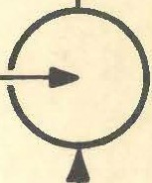

I

■

C. C>,._.,Qt,,..._;

I r 1, 1'

•

C04D *,=s,:_..-..::,.*

' ' ' ' I r

*SPE,vT :5,._....._G*

*Ta c, ,..,.,o*

l l -



j •

7/ -

*No'r .:s,..._o- ,1:,ec,""1 _.,..,...-y*

*AlloT"* ., 4G

" u "

&AS

*p,14«0*

*••,r,r,,,,.,.u.,•,<~­*

' , 1

n

**.A.,,.,e.**

***M•M&o* c»c,oca.** _ ***'5/Hrllli!.***

-

*Dli.UT/ON AIR*



-

*/D. C°-4..AJ*

======== J- -.1<::;A$ **,.,All!D1-=====:!. -.1**

**:==========--- -w** *H,"' ""'1'""<* - 1 '

*, • ...z:-* dlC:.A•T */1=<..J ,,.,,..ca*- """'9 *v* '--"'-'NO•.C-

*/N* C:.*""'0* <.«S •  *IVA.<:•*

**t... A/1¥n«.**

l I j

**•M•ca**

'

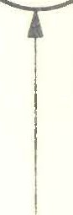**ey "1/U•~,..c•**

**''-="O *..CUM,--0.***

..

Al ,,  --·

l **l** j •



I

I

I I I I

**Lv•c,aco**

*F-U•'-* **J'4"'-44S.**

'

/4--.n

....

j

c...:n.:::><&:5

! **..5711>.C.......•** *7o*

***a..--.c.lw(.)***

. ._ /

I I I I



-

LOIIDOII. **11.W.1-** •-IT I I

|  |  |  |  |  |  |  |  |  |  |
| --- | --- | --- | --- | --- | --- | --- | --- | --- | --- |
| **BABCOCK** & **WILCOX L** TO. | THIS **OIISIGN IS** THI **,110Plll.TY OP**  **aAICOCK** I WILCOX LTD. '11(D II |  | | **lllVISIONI.** | |  |  |  |  |
| **DIIAWNa** | . | I | I |
| **BABCOCK HOUSE, 209 EUSTON RD.,** | ONLY A.1.1.0WID TO II USID IY  **1x,111n ,111MIUION AND** LICENCE | *MA,E.IZIAL.S* | *J="Lo"""'* | *.D/.4...t:3,e* | **DRG. N°·** *J. 7050 JS 2 B* |
| :;v-- | | I | I |

•

DE-LEADING PLANT.

. ,,

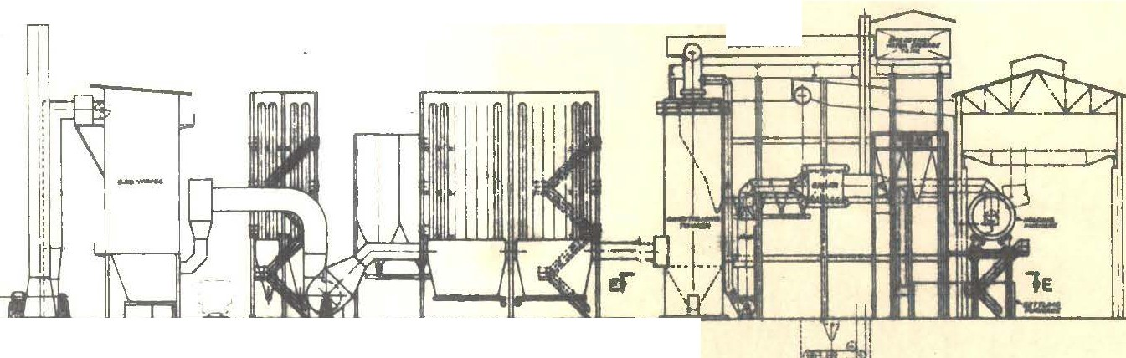

" I

L.. f_.J

I: II

, *,-""J"* I:

V 1il

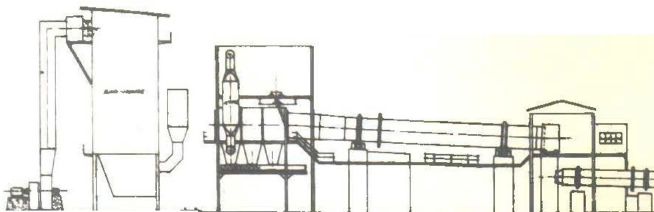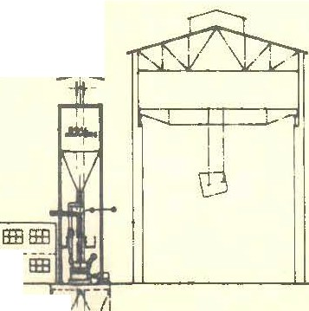

.-:t.--

IEH-1-

SECTION **B·B**

l\ *1*

I

i -o-1-3--4!1]

I

' t -

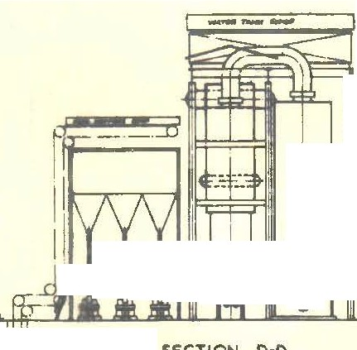

##### ·\l/

COAL PULVE.R.lZ.ER.S ,1 l='UMI:. .

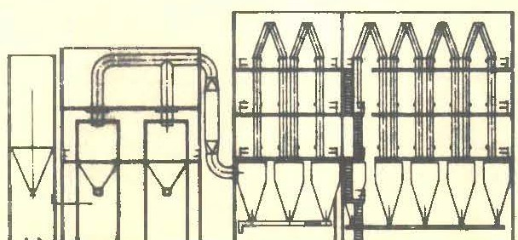.,....._

SlCTION **A·A**

FUMl"1 PLANT. •

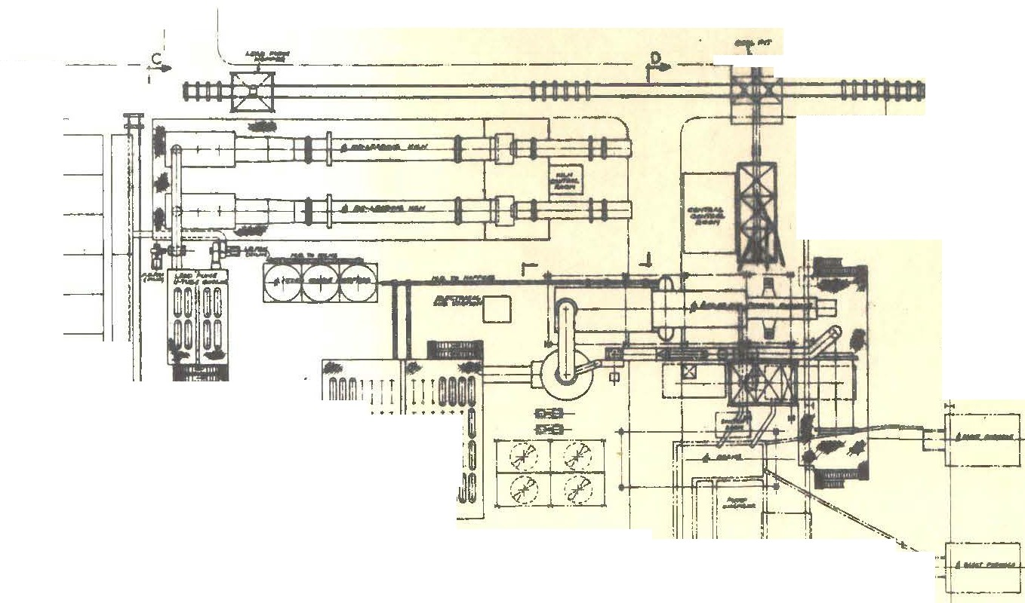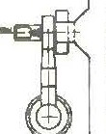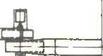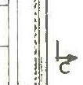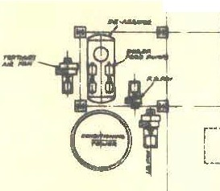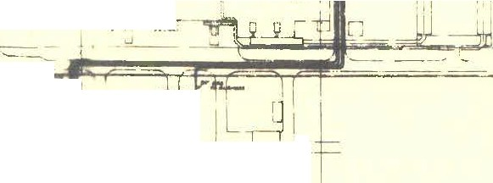

,--··

##### ·it

SECTION C-C

U-TUBE COOLElc!. S,

I I tel- Lt

, ,_.,

/"-------

*I.*

--f:i::j-·-. _;--1:=

,r,- --1-·-·r ,_ .

I Di#"t

r- -i

t,--

I

...t_

· *(* •L

I • I

I I

\

I

')

!

!ILJ

! ;

Qlltt liJ

fWllrrltl1ll1lmJ 1J1l1lrltpll 11lfil1 1 r T 1 l Tl' **mm** Wllll t J J: 1 l. 1111111

1cr

t

# t

L '--·1 ·11 -=:=

7

T -

- - L•.. .,

! ® l

**Ja**

I I d,

SECTION E·E L ...J

1l

_I . q, ---1L

I "•-"++h- ' i,JL-

.J..+;:;:;.-

°' i *r,-r::·* :;w -*m*r=I I:fj

j, **1----f;ft!f-** -,l 1=-'1. -1

I I' • ·• r ,,

, I -- ..,j I

-- l

**PLAN**

I 1·".:::'A

L_

\ rrr1 I I I I

-

*1* L *(*

I

- ---- KEY PLAN

**&.A..arnc:r:: a wu *rnv* I T'n** -**1** ~----N i- -----.-.-.,.- j T<!'I& *,!_lf:IJl:'0.&I* ***.&lilOAT. I"'>&*** *7JI\N"*

•

##### r

FROM F LIMING PLANT

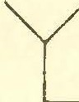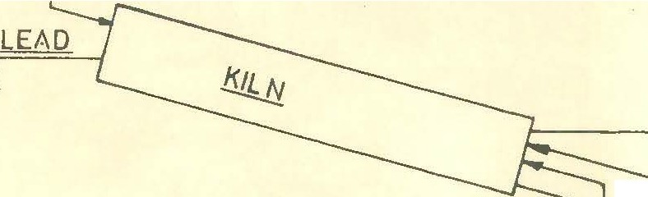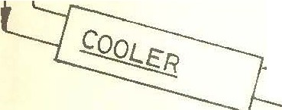

RETURN

MIXED

OXIDE

COKE

INKER

KILN A CRETIONS

STACK

BAGHOUSE

FUME

LEAD FUME TO GERMANIUM PLANT

HOT CLINKER

PRODUCER GAS COMBUSTION AIR

COOLING AIR

RETURN CLINKE

- DELEADING PLANT - FLOW SHEET

ZINC CLINKER

STORAGE

L MARKET



•



*'r*

*r:i Ci* J

.J

*J)*

LIME

ri

*0*

-.J

0-

,J

u

*<(*

uJ

.)

:r

*-t.*

w

l·h.o

**l**

-z

*1*

I.I

UJ

*l*

t:-

1-lzSo

NaCP





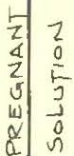





*-1_* U) Rc.c.LAIME:D Hc.e..

I::-

*1.* I)

H--z. So-+

2 *1*

4. 0

I- *\)*



HYDR0LY$1$

-





G ER **M A..t--..1** I UM